

**Climate change: How can farmers help to reduce the impact of food waste?**

**A set of resources to help introduce KS3/4 students to the realities of climate change. Focusing on the impacts, causes and solutions.**

**Content**

* Teacher’s notes
* PowerPoint (12 Slides)
* Activity 1 – Food waste knowledge quiz
* Activity 2 – Comparison of students’ food waste diaries – will need at least a weeks preparation
* Activity 3 – Utilising excess farm produce

**Teachers Notes**

These resources could be used to deliver a single lesson focusing on food waste, within the context of climate change; and the impacts, causes and possible solutions associated to sustainable food production. Alternatively, by incorporating some of the suggested additional activities, a sequence of lessons could be developed. Additional teaching suggestions are included as notes within the PowerPoint. Some preparation is required for both of the activities included.

**Curriculum Links**

**GCSE Food and Nutrition** – environmental impact and the sustainability of food and the environmental issues associated with food. The impact of food and food security on local and global markets and communities.

**GCSE Geography** – climate change effects and management, ecosystems and urban sustainability. The changing demand and provision of food, and the associated opportunities and challenges. Food insecurity and the different strategies to increase food supply. Energy insecurities and sustainable sources.

**GCSE Design and Technology** – renewable energy sources.

Completing suggested additional activities would also provide links to several other curriculum areas including **English, Maths and Business Studies.**

**Suggested Teaching Activities**

* **Begin by**: Using the PowerPoint to display **slide 2.** This is theKey Language (vocabulary). You may wish to use this as an opportunity to check pupils’ existing knowledge.
* **Then**: **Ask: What is food waste?** Discuss as a class what they know already about food waste**. Use: Activity 1 – The Food Waste Quiz (**answers are on **slide 4**.) to see how much the students think they know. Use the quiz to explore why so much bagged salad is thrown away. Is it because the salad wilts more quickly in a bag, and if so why do consumers continue to buy it? So, what is food waste, using **slide 5** as a prompt ask the students to discuss in pairs when they believe food waste begins in the field to fork story, which leads into…

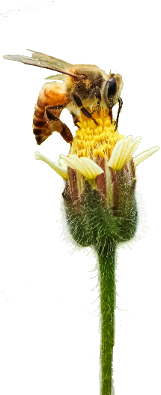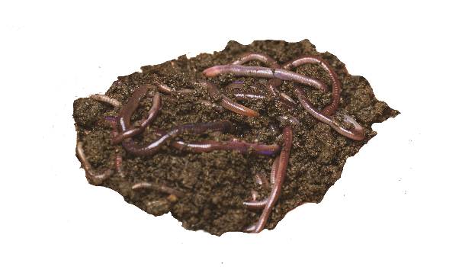

* **How is food waste different to food surplus and why is it important to know the difference**? The definitons of food waste and food surplus (according to WRAP) are shown on **slide 6**; do your students agree? Is it easier to reduce food production so that there is less surplus or waste less once it has been produced?
* **How does food waste contribute towards climate change?** Watch the UN video on **slide 7** for an introduction on the land, water and habitats wasted along with the greenhouse gases unnecessarily produced.
* Consider the data table on **slide 8**, and identify the likely causes of food waste within households:
  + Cheap food means that UK consumers are comfortable to throw away food that is perfectly edible. Read this Which report for more detail - [See how food prices compare to 30 years ago and you might be surprised – Which? News](https://www.which.co.uk/news/2019/11/heres-how-our-food-prices-compare-to-30-years-ago-and-you-might-be-surprised/)
  + Consumers lack the knowledge and skills to use leftovers, increasing wastage
  + There is a lack of understanding of ‘use by’ and ‘best before’ dates so food is thrown out unnecessarily
  + The food market is controlled by ‘a few’ large companies that can control the prices charged, the supply of produce and who use effective marketing to encourage over-buying of food, meaning that consumers buy more than they need and throw away what they don’t eat
* **Activity 2: Compare the results of the students’ food waste diaries** – this activity will need to have been set at least a week in advance if the diaries are to contain enough data. As a class, consider the following issues:
  + Could the food have been used in an alternative way to avoid being disposed of?
  + Did most of the food waste fall into one of the following categories:
    - Salad
    - Vegetable
    - Fruit
    - Processed
    - Meat
  + Did the storage method for the food item affect its shelf life?
  + Were the foods past their ‘use by’ or ‘best before’ date, and what does that mean?
  + Is the disposal of food waste worse if the food miles are higher for that item?
  + What could be done at home to reduce food waste?
* **Now:** Use the photos on **slide 9** to prompt discussions around the likely causes of food waste from the farmers’ perspective. What other reasons can the students think of that aren’t mentioned on the slide?
* **How can farmers ensure that they are not left with produce that they cannot sell?** Watch the video on **slide 10** to meet a Sainsbury’s supplier and learn how they are managing their farm to minimise climate change. Discuss as a class how the farmer could also avoid food waste?
  + Careful planning to ensure that crops planted will meet the needs of the market when harvested and processed.
  + Informed decision making, to minimise the risk of planting too much of a crop
  + Experience and knowledge of the crop, so that pests can be effectively controlled and that all fo the crop can be harvested



* + Reliable infrastructure to ensure that harvested crops can be transported to the processing plant withour being damaged or perishing……..
* **How can food waste be utilised effectively?** Using the video from GENeco - **slide 11** - to introduce the use of anaerobic digestors and alternative energy sources, begin a discussion around how farmers can use food waste to benefit their farms,
* **How can farmers help to minimise food wastage?**
  + What action would you take? Students are asked as farmers to imagine how they would minimise food wastage on their farm - **slide 12**. Websites which may be useful are:
    - **Waste and Resources Action Plan - WRAP –** www.wrap.org.uk
    - **National Farmers Union – NFU** **-** [Taking a different approach to food waste (nfuonline.com)](https://www.nfuonline.com/cross-sector/environment/waste/waste-news/taking-a-different-approach-to-food-waste/)
    - **The Gleaning Network -** [Gleaning Network - Feedback (feedbackglobal.org)](https://feedbackglobal.org/campaigns/gleaning-network/)
    - **Driven to Waste:** Global food loss on Farm report – WWF - [driven_to_waste_summary.pdf (panda.org)](https://wwfint.awsassets.panda.org/downloads/driven_to_waste_summary.pdf)
  + **Activity 3 – Class discussion – What should a farmer should do with excess produce?** Students may like to explore the options open to a farmer who has unexpectedly been left with extra produce of their choice (chicken eggs/wheat grains/turkeys/tomatoes/hay).
    - Students can explore alternative markets for produce,
    - Design a recipe to encourage more demand.
    - Research into local charities that will collect excess food items
    - How could the produce be used on the farm, what animals might like to eat it? How would it benefit the soil if it was to be dug in, are there any other uses, such as encouraging wildlife or attracting tourists?

**You may also like to:**

* **Explore Global Food Waste** - Tristram Stuart is the founder of an organisation called Feedback. The Global Food Waste Scandal is a 15 minute film of a TED Talk in which he summarises his thoughts and ideas about global food waste: <http://feedbackglobal.org/food-waste-scandal/> (Teachers might wish to watch the film in advance, to divide it into sections for their pupils to discuss in more detail.)
* **Debate –**Divide the class into teams with pairs of teams preparing to present or oppose a particular statement…
  + We believe supermarkets are wholly responsible for all our food waste.
  + We believe education about healthy eating and shopping habits is the only way to tackle the food waste crisis.

**Have you considered a farm visit?**

Farms around the world are working hard to combat climate change. A farm visit is a unique way to discover how climate change may impact our food production and what farmers are doing to make changes.

Organisations such as [**LEAF Education**](https://leafuk.org/education/leaf-education) work with schools and landowners to encourage visits to the countryside. The Regional Educational Consultant for your area would be more than happy to offer help and support if you felt this is something you would like to consider.

You may also like to consider taking part in [**Farmer Time**](https://leafuk.org/farmertime/home) (a regular virtual link with a farmer and your class)

