**Water management – KS4 and 5 Field Trip**

**(Applicable to visits to pumping stations, flood defences,**

**rivers/watercourses, sluices/weirs, locks etc)**

**Section 1: Introduction**

**Water management systems**

Water management systems are an essential, but often hidden, part of our landscape. They are used all around the country, but especially in lowland areas, to manage water levels in order to reduce the risk of flooding, maintain water supplies for irrigation, or control levels up or downstream of the system for ecological, navigation, or other purposes.

Water management systems include: pumping stations, sluices, weirs, flood defences, locks, and not forgetting the rivers and watercourses themselves.

**Planning a visit**

This pack is designed to support a Key Stage 4 or 5 Geography visit to a water management system. It contains some pre-visit discussion topics, guidance on conducting your risk assessment, and what to expect from the visit.

In this section, you will find links to sources of additional information so that you can plan a successful and safe visit for students to a pumping station, watercourse, flood defence, sluice, weir, lock, etc.

In advance of the visit, students should be reminded about the expected levels of behaviour and co-operation, in particular briefed about handrails, steps and walkways, listening carefully to instructions, safety around water and in the car park.

Also, it is worth pointing out to students that the site is not a museum, but a working water management system vital to the local lowland flood defence network and may be operational depending on the prevailing conditions on the day.

It is the responsibility of the school making the booking to do a site visit and carry out a Risk Assessment well in advance of the visit. If you require any further information to help you compile a risk assessment or to carry out a familiarisation visit, please get in touch with the relevant Internal Drainage Board. All hazards and control measures related to activities near watercourses should be addressed.

The Risk Assessment example attached using the Royal Geographical Society template (available for download from the Useful Guidance section below) is designed to assist, but not replace, that task.

During the introductory talk, the Site Manager will advise students of potential hazards and the emergency evacuation procedures in the event of an incident.

**Recommended guidance**

Visit My Farm and Royal Geographical Society websites have useful guidance and resources on Health & Safety, Risk Assessment, Water Safety and Fieldwork Planning.

**Royal Geographical Society**

* <https://www.rgs.org/in-the-field/fieldwork-in-schools/fieldwork-safety-and-planning/risk-assessments/>
* <https://www.rgs.org/schools/fieldwork-in-schools/fieldwork-safety-and-planning/>.

**Learning objectives**

Students will:

* Be able to explain the purpose of a pumping station (sluice or weir) in managing water levels and reducing flood risk
* Understand the role of an Internal Drainage Board (IDB) in reducing flood risk to people, property and infrastructure, and manage water levels for agricultural and environmental needs
* Be able to explain water management strategies (as applicable to visit) – river maintenance, dredging, bank management etc and understand that these are conducted in accordance with environmental duties and the promotion of ecological wellbeing of the area

**Section 2 - In advance of the visit**

Teacher led discussion around ‘Who manages our water levels’?

**Management of Water Levels - A Shared Responsibility**

Anyone who has ever tried to dig a hole on the beach is familiar with the problem: the deeper you dig; the more water flows into the hole. In a sense, many lowland parts of England are like such a hole. Much of the land here lies below sea level, so we needed ditches, windmills, sluices, and weirs to pump the water out. Right from square one, draining water from our land has always been a struggle, because the water will always try to find its way back to the lowest point.

In a rainy country like the UK, where rivers determine the lay of the land, flooding is an ever-present threat. Heavy rainfall is not the only problem, however. Subsidence of the soil, collapse of flood defences, and tidal surges have each caused their fair share of disasters in the past.

Since nobody can withstand so much water alone, the authorities, farmers, and citizens decided to join forces and team up in organisations called **Internal Drainage Boards (IDB)**. Now, nearly a thousand years later, many low-lying parts of England would be permanently flooded if IDBs would stop working.

IDBs are local public authorities that manages water levels and flood risk in areas of low-lying land where there is special need for drainage. These areas are called drainage districts and they cover about a tenth of England. Much of an IDB’s work involves maintaining and improving watercourses, drainage channels, outfalls and pumping stations. They carefully manage water levels to reduce flood risk and protect people, property and infrastructure whilst balancing the needs of society and the economy with the environment.

IDBs don’t do this on their own. There is no single authority responsible for managing water level and flood risk in England, rather there are multiple organisations to manage the various different types of flooding.

The **Environment Agency** is responsible for water level and flood risk management activities on main rivers and for regulating reservoir safety and providing river flood warnings.

**Highways Authority** is responsible for fixing drainage and flooding issues on highways and roads. This includes blocked drains and gullies on the roads, however they are not normally responsible for ditches alongside roads. In most cases the responsibility is with the adjacent landowner.

**Highways England** is responsible for drainage of the motorways and some of the A roads.

**County Councils / Lead Local Flood Authority** are responsible for co-ordinating the management of flood risk from surface water, groundwater and ordinary watercourses. This does not mean that they can or will undertake works to deal with a flooding issue but they can investigate to find out who the riparian owner is and therefore who is responsible and advise on potential solutions.

**District / Borough Councils** are responsible for reviewing flood risk in planning applications. They have the power to carry out works on ordinary watercourses to deal with local flooding issues.

**Water and Sewerage Companies** are responsible for managing the flooding and flood risk from public sewers and water mains. This includes making sure they can maintain essential water supply and sewerage services during a flood.

**Riparian Owners** are responsible for maintaining the watercourse or ditch running through or adjacent to their land as well as the vegetation on the banks, in order to allow water to flow naturally and prevent flooding.

**ADA is a membership organisation** that represents drainage, water level and flood risk management authorities in the UK.

**How do IDBs manage water levels? Example from Somerset**

The **Somerset Drainage Board Consortium** manages two drainage boards in Somerset; the Axe Brue IDB and the Parrett IDB. These two boards carry out water level management in the Somerset Levels. The land in much of this area is between only two and six metres above mean sea level. This makes water level management vital for the existence and development of both the urban and farming communities. Drainage channels carry excess water away. This water discharges into main rivers.

The IDBs work to keep these watercourses clear of obstructions, dredging and managing vegetation, and constructing and controlling water management systems such as weirs and sluices. This work benefits the people who live and work in the low-lying land. It also helps provide water to areas (known as islands) which are naturally raised above the Levels.

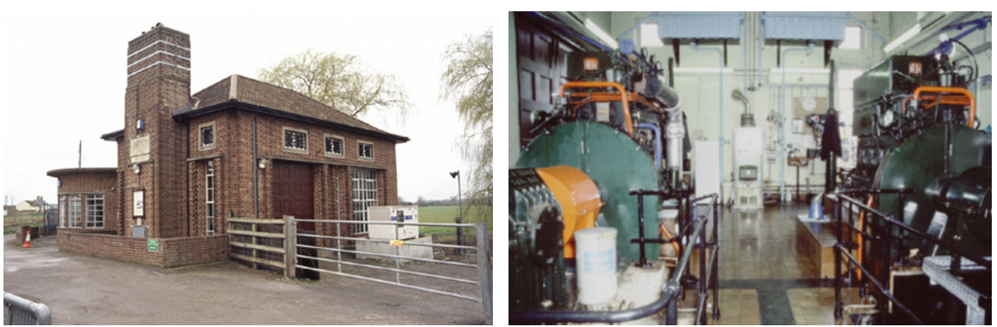

Photos 1 & 2: Outside and inside a pumping station on the Somerset Levels

Pumping stations remove excess water from the area. In Somerset these are managed by the Environment Agency. For example, pumping water from the North Drain into the Brue, as and when required, helps to avoid flooding on 9,700 acres of land.



Photo 3: Dredging in progress (Somerset Rivers Authority)

**Section 3 - During the visit**

The questions below could be used as part of the introduction to the pumping station and to demonstrate how the management of water levels and the work of the IDB has a wider benefit to society, businesses and infrastructure in the area. This could be followed up during a tour of the IDB with a field sketch activity (see Field Sketch worksheet) to point out key features whilst sitting at a point where there is a clear view across the drainage basin.

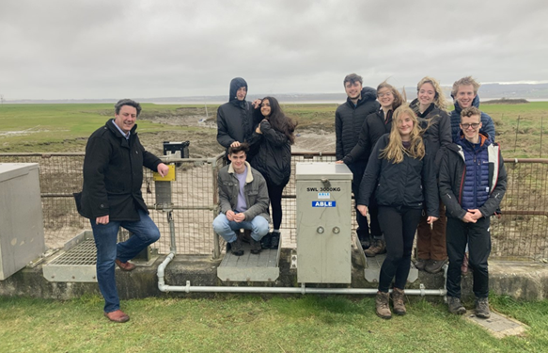

Photo 4: Drainage engineer James Thomas from the Lower Severn Drainage Board with year 13 students from Alcester Grammar School.

**Q1 This image shows a village centre that has been flooded. Who and what might be affected by this?**



Photo 5: Flooding in the Somerset Levels

**Q2 Can you suggest other reasons for managing water levels in addition to reducing flood risk?**

The Benefits of Water Management worksheet can be used to get students thinking about all the benefits that sustainable drainage management can provide to communities.

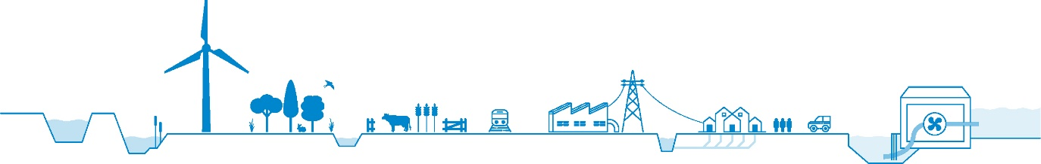 Diagram 1: Beneficiaries of water level management

Discussion could cover the following areas (left to right on diagram above);

* Renewable energy supply
* Environment
* Agriculture
* Transport
* Industry and Commerce
* Utilities and services
* Homes
* People and communities

**Section 4: Walk around the water management system**

**(Pumping station, watercourse, sluice, weir, embankment etc)**

Students to record observations, make additional notes and take photographs during the walk.

Ambassador led walk to highlight key aspects of the water management system, and work undertaken to manage water levels and reduce the risk from flooding locally. This could include:

* Its history
* Why it was built
* How it has changed over time
* How it works
* How it is controlled
* How it is managed and maintained

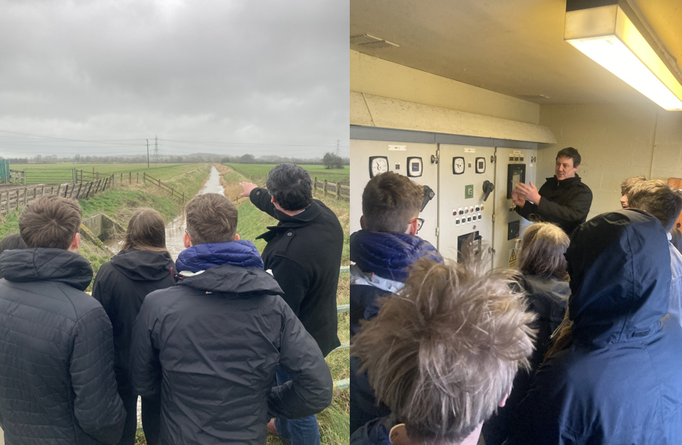

Photo 6 & 7: Alcester Grammar Sixth Form students at the Lower Severn Pumping Station near Oldbury on Severn.

This could be used to explore:

**Water management strategies;**

* Pumping
* Maintenance and bank management - grass cutting, flail mowing, weed control, clearing vegetation, bush cutting
* Watercourse improvement
* Dredging
* Planting trees
* Removal of blockages or obstructions in the channel / watercourse
* Maintenance and repair of existing structures, e.g. sluices

**Promoting biodiversity and ecological wellbeing;**

* Conservation of plants and wetland wildlife
* Providing wildlife rich habitats and protecting endangered species (great crested newt, otters, water voles etc)
* Restoration work
* Maintaining Sites of Special Scientific Interest (SSSI)
* Managing badger burrows / invasive and non-native invasive species
* Fish /eel friendly passage at pumping station
* IDBs have their own Biodiversity Action Plan in line with a number of environmental duties