







**Different Types of Bread**

During the live stream from the grain processing facility at the Great Tew Estate, Kate will explain how the wheat is processed to make different types of bread.  Please listen carefully and answer the questions below:

**Activity A**

Label the diagram of a wheat grain below and answer questions 1 and 2.

Q1. Explain why wholemeal bread is more **nutritious** than white bread.

______________________________________________________________________________________________________________________________________________________________________________________________________________________________________________________________________________________________________________________________________________________________

Q2. Explain why wholemeal and rye bread has more **fibre** than white bread.

_________________________________________________________________________________________________________________________________________________________________________________________________________________________________________________________________________________________________________________________________________________________________________________________________

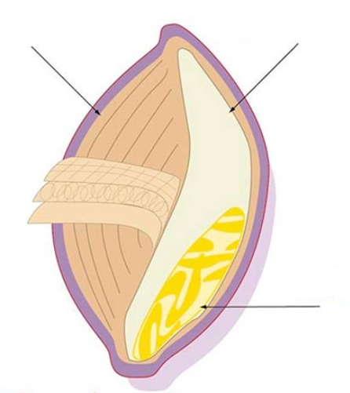

Q3. What is the **process** used to make supermarket sliced bread called? __________________________

**What is gluten?**

Gluten is a family of proteins found in grains, including wheat, rye, spelt, and barley.

The two main proteins in gluten are glutenin and gliadin. **Gliadin** is the protein which is responsible for most gluten allergies including coeliac disease.

When flour mixes with water, the gluten proteins form a sticky network that has a glue-like consistency. This glue-like property makes the dough elastic and gives bread the ability to rise during baking.

Q4. What **ingredients** are commonly added to

reduce the **processing time** and increase

the **shelf life** of sliced bread?

a) _______________________________

b) _______________________________

c)________________________________

d)________________________________

e) _______________________________

f) ________________________________

g) ________________________________

Q5. List three things the staff test the grain for at the onsite laboratory

_________________________ _________________________ _________________________

Q6. How many loaves of bread are **produced** every day in the UK?  ___________________________

Q7. How many loaves of bread are **wasted** every day in the UK? ____________________________

**Coeliac Disease**

**Epidemiology:** 1% UK white population; 2x more common in F>M

**Pathophysiology:** Inflammatory disorder which primarily affects

small intestine caused by exposure to gliadins (protein in gluten, see above!)

**Symptoms:** Tiredness, steatorrhoea, weight loss, anaemia, abdominal pain, osteoporosis

**Diagnosis**:** History, Blood tests (antibodies including anti-transglutaminase IgA), Biopsy of bowel wall via endoscopy (villous atrophy, crypt hyperplasia, chronic inflammatory cell infiltrate in lamina propria**)**

**Treatment:** Gluten Free diet

*\*\* These diagnostic tests must be done when the patient is actively consuming gluten, otherwise autoantibodies and histological changes may disappear whilst on a gluten-free diet*



**Activity B**

Fill in the table below by matching up the types of bread from the list of names in bold and list the pro’s and con’s of each type.

**WHOLEMEAL WHITE SOURDOUGH WHOLEGRAIN RYE MULTIGRAIN OAT TRADITIONAL RECIPE**

|  |  |  |  |  |  |
| --- | --- | --- | --- | --- | --- |
| **Picture of bread** | **Type of bread** | **Suitable for coeliac?🗸 or X** | **How the bread is made** | **Pro’s** | **Con’s** |
|  |  |  | Made using only the starch part of the grain using CBP |  |  |
|  |  |  | Made using flour from oats, coeliacs should not assume that this bread is gluten free, always check the label! |  |  |
|  |  |  | Made from the whole wheat grain using CBP. |  |  |
|  |  |  | This is made with a mixture of grains using CBP. |  |  |
|  |  |  | Made with a mixture of grains fully intact such as wheat, whole barley, brown rice and more, all high in fibre and nutrients. |  |  |
|  |  |  | Can be any of the types of bread above but using the traditional ‘Bulk Fermentation Process’ instead of CBP |  |  |
|  |  |  | Can use any flour but made using a ‘starter’ containing naturally occurring yeasts, resulting in a more sour taste. |  |  |
|  |  |  | Made from rye grain, which is typically higher in fibre and denser than wheat bread. |  |  |