

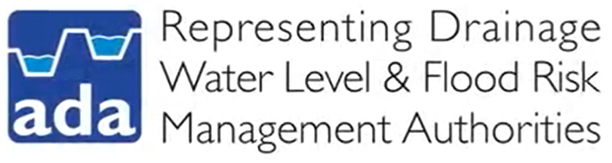

**Teacher Notes – Fenlands**

This activity pack developed by the Association of Drainage Authorities in collaboration with LEAF Education has a number of resources that can be used to deliver a whole case study about flood management in the Fenlands over the past decade.

**Causes and Effects of Flooding in the Fenlands**

There is a Kahoot quiz link included in the PowerPoint (a Kahoot guidance sheet is included if needed) which can make an ideal starter activity, this can then be followed with a look at the resource booklet, sources A and B can be used to assess and generate discussion about the causes of the Wainfleet floods. The Impacts caused by 2019 Wainfleet floods resource includes statements with facts and figures on that students can read and be challenged in pairs to put into groups social, economic and environmental.

**Solutions to Flooding in Fenlands**

In addition, theworksheet exercise can be used alongside the resource booklet, as well as Source C- Flood Management Strategies in the Fens being a fantastic way of learning about the very latest strategies being used to manage water levels sustainably for the future. The worksheet is designed to review what has already been taught previously about factors affecting water levels and the flood hydrograph, answers to the questions in the worksheet are all in the PowerPoint and can be gone through as a class to check their answers.

**Who is Responsible for Managing Flooding in the Fenlands?**

A Level students may find the Water Management Cards are a useful activity where pairs or small groups of students can discover that flood management is the responsibility of many organisations collaborating together. A mature discussion can be generated about what challenges this situation can lead to during times of emergency. Students simply need to match up the type of organisation with a definition and find the corresponding picture of an example of each organisation within the Fenlands.

A discussion can then be generated about how all these organisations join forces and team up in organisations called Internal Drainage Boards (IDB)and that many low-lying parts of England would be permanently flooded if IDBs would stop working.

**Why not follow up with a Field Trip?**

Why not organise a field trip to your local internal drainage board to hear from drainage engineers first-hand about the strategies that they use to carefully manage water levels to reduce flood risk and protect people, property and infrastructure? Engineers will be able to show the students examples of how flood management is achieved whilst balancing the needs of society and the economy with the environment, and students will be able to ask questions and learn about possible careers in the important role in sustainable land management.

See **Visit Your Local Drainage Engineer** for everything you need to know to organise a trip.