Fenlands – Resource Booklet





**Source A**

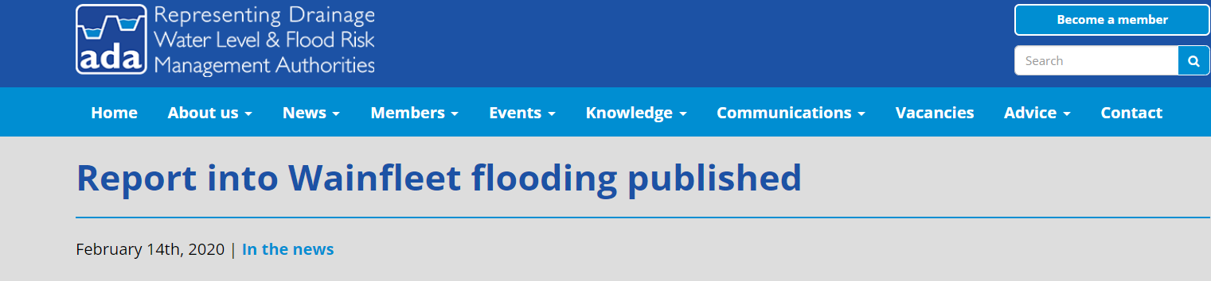

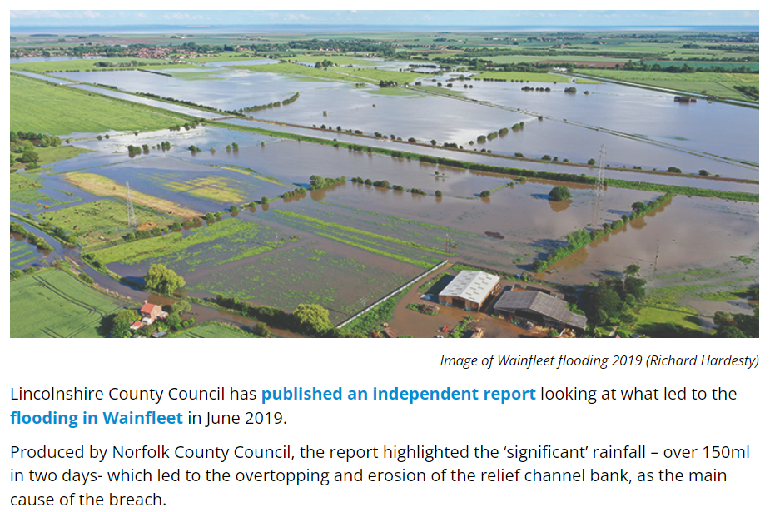

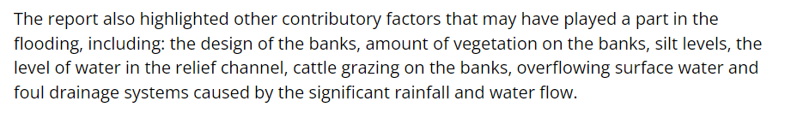

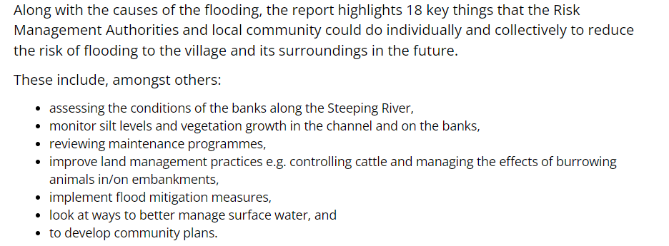

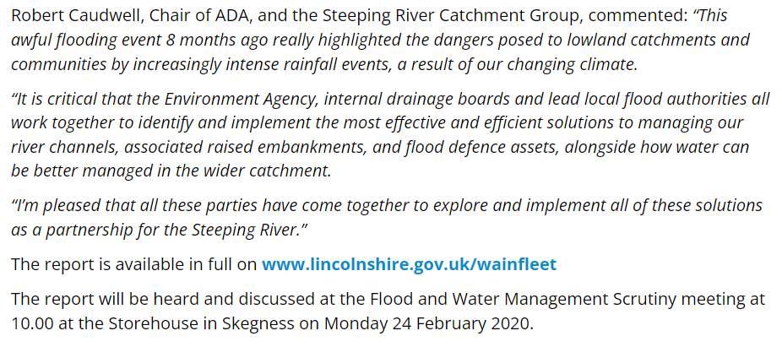

**CAUSES OF WAINFLEET FLOODS 2019**

The Wainfleet floods hit the national headlines in summer 2019 and February 2020, the extensive floods were caused by a number of factors:

*Lincolnshire Live.co.uk*

* Prolonged heavy rainfall saw 2.5 times the monthly average fall between 10-12 June 2019 in parts of Lincolnshire causing overtopping of the bank and a breach on the relief channel.
* The surrounding land is reclaimed from peat and marshland, lying only slightly above sea level and below the height of the embanked river and Relief Channel.

**Source B**

* Accumulation of silt in the relief channel potentially contributed to water levels reaching higher levels
* Overflowing surface water and foul drainage systems caused by excessive rainfall and water flow
* The embankments of the relief channel lacked the protection of modern flood defences.
* Areas of the river bank had been grazed by cattle and rutted by their hooves and vehicles, which may have caused weakening, making it more susceptible to breaching.
* Relief channel had higher water levels kept for water abstraction in the summer months.

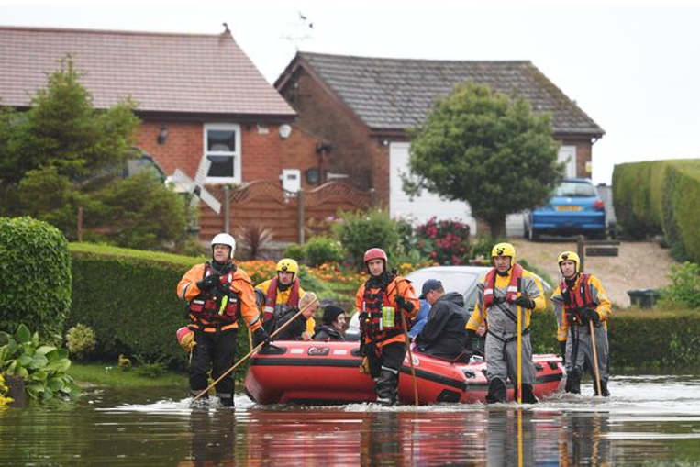

*Association of Drainage Authorities*

