**Flood Management - The Fens**

1. Complete the flood hydrograph (Fig 1a) for the River Steeping below by drawing on bars to represent the rainfall data in fig 1b. (5 marks)
2. Give your completed graph a title. (1 mark)

_______________________________________________________________________________________________________________

**Fig 1a**

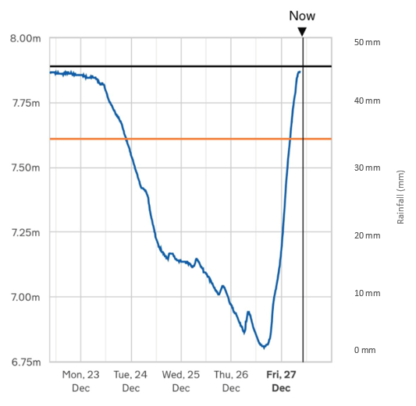

**Fig 1b**

|  |  |  |  |  |  |  |
| --- | --- | --- | --- | --- | --- | --- |
|  | **Mon 23 Dec** | **Tue 24 Dec** | **Wed 25 Dec** | **Thu 26 Dec** | **Fri 27 Dec** | **Average** |
| Rainfall | 4 mm | 6 mm | 11 mm | 29 mm | 18 mm |  |

1. Complete Fig 1b by calculating the average rainfall for Monday 23 to Friday 27 December, use the space below for your working out.

________________________________________________________________________________________________________________________________________

(1 mark)

1. Estimate the lag time between peak rainfall and peak discharge.

____________________________________________________________________

(1 mark)

1. Farmers living close to the River Steeping report that when it rains on the surrounding hills it takes only a day for the water to reach the river compared to thirty years ago when it would take much longer. Explain why the lag time has shortened during recent years.

____________________________________________________________________________________________________________________________________________________________________________________________________________________________________________________________________________________________________________________________________________________

(3 marks)

1. Read through **Source C** in the resource booklet.

Using examples from source C outline some of the arguments for and against hard engineering.

________________________________________________________________________________________________________________________________________________________________________________________________________________________________________________________________________________________________________________________________________________________________________________________________________________________________________________________________________________________________________________________________________________________________________________________________________________________________________________________________________________________________________

________________________________________________________________________________________________________________________________________

(6 marks)

1. How can drainage basin management strategies be made more sustainable?

________________________________________________________________________________________________________________________________________________________________________________________________________________________________________________________________________________________________________________________________________________________________________________________________________________________________________________________________________________________________________________________________________________________________________________________________________________________________________________________________________________________________________

(5 marks)

1. Many conservationists argue that flood affected areas are all too often built on the floodplains; experts therefore argue that to some degree flooding is a problem of our own making.

Do you agree with this statement?

________________________________________________________________________________________________________________________________________________________________________________________________________________________________________________________________________________________________________________________________________________________________________________________________________________________________________________________________________________________________________________________________________________________________________________________________________________________________________________________________________________________________________

________________________________________________________________________________________________________________________________________________________________________________________________________________________________________________________________________________________________________________________________________________________________________________________________________________________________________________________________________________________________________________________________________________________________________________________________________________________________________________________________________________________________________

____________________________________________________________________________________________________________________________________________________________________________________________________________________________________________________________________________________________________________________________________________________

(10 marks)

Extra space

________________________________________________________________________________________________________________________________________________________________________________________________________________________________________________________________________________________________________________________________________________________________________________________________________________________________________________________________________________________________________________________________________________________________________________________________________________________________________________________________________________________________________