**Playdough recipe**

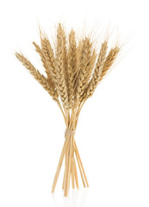Dry Ingredients:

2 cups of plain flour

1 cup of salt

4 teaspoons cream of tartar

Wet Ingredients

2 cups of cold water

3 tablespoons of vegetable oil

Food colouring of choice (powdered food colouring works best)

Food Flavouring (vanilla, strawberry, etc), glitter (optional) or herbs

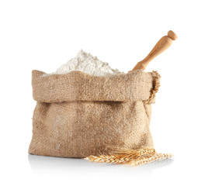Equipment:

Large saucepan (an old one will do)

Cup or mug

Wooden spoon (an old one will do).

Airtight container

Cling film or plastic bag

Method:

1.Measure out the dry ingredients (flour and salt) using a standard cup or mug. Add all the dry ingredients together.

2. Next, using the same cup or mug add 2 cups of cold water. Add the vegetable oil. *If you need more oil, you can add a bit more, you don't want it too dry or too oily.*

3. Add food colouring gradually until you are satisfied with the colour and stir in carefully with a wooden spoon. If you want to add a food flavouring and/or glitter, mix it in now as well but this optional.

 4. Make sure all the flour is mixed in properly. It will appear lumpy, but it will come together.

5. On a low heat, place the saucepan on the hob and keep gently stirring making sure all the sides and the bottom of the pan are stirred properly.

6. The mixture will start to thicken and start to form a dough. The play dough will be soft but pliable. This is when you know it is ready.

7. PLEASE BE CAREFUL as the playdough is very hot. Put a little oil on your hands and take the playdough out of the saucepan.  Knead it for a bit and divide it into big or small balls. You can wrap it in a clean plastic bag or wrap it in cling film. Keep it in an airtight container.

Tips:

If the playdough is too dry add a bit more oil when it's still warm and knead it in until it is the correct playdough consistency.

If you have too much playdough, put it in the fridge it will last longer.  When you need it take some out and either put it on the side to get to room temperature or a quick blast in the microwave 10 -20 seconds will take the chill off it.

You can make the play dough without heating it on the hob but it doesn’t keep for as long. Use the same measurements as above but instead of adding all of the water add a little at a time and make the dough similar to as you would make it for pastry or chapatti. Not too hard or too soft.