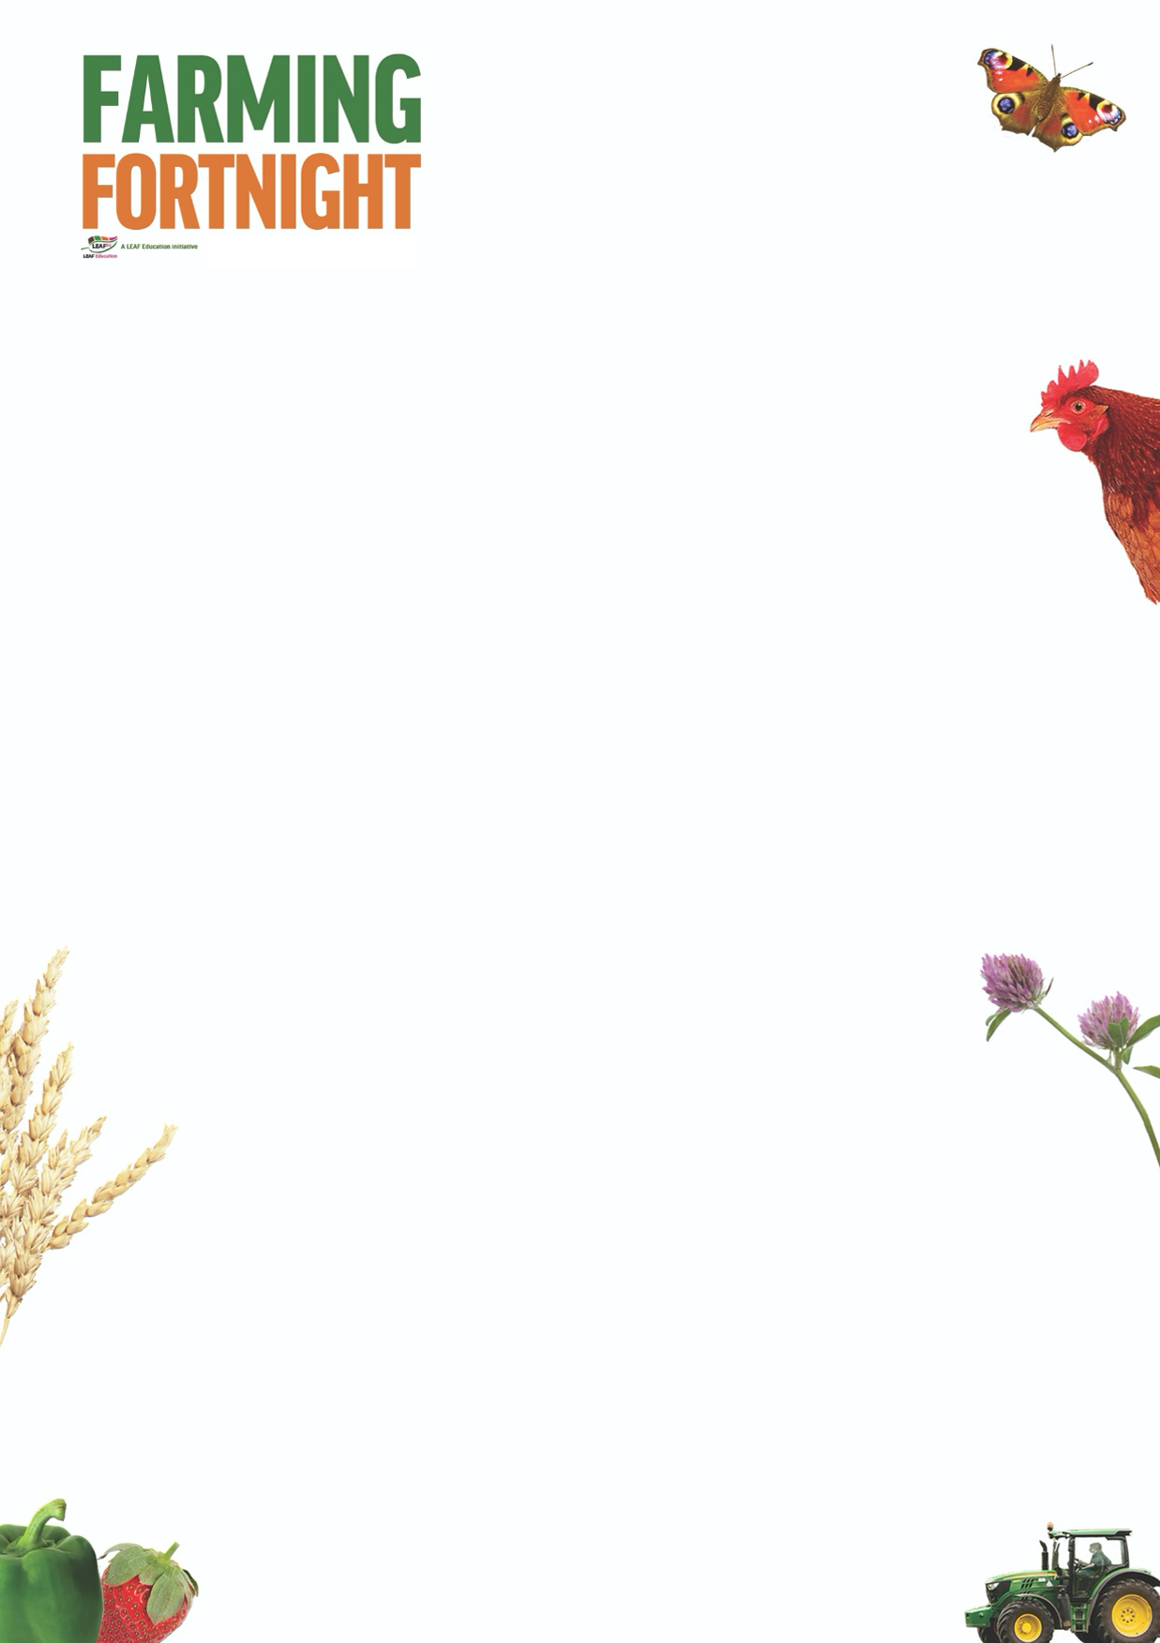

**Woodland: EYFS**

This session allows pupils to consider what a woodland area is and what they might find in a wood. They can take a closer look at trees; their structure and how they change through the seasons. Pupils can also consider which animals might be found in a woodland area.

**Introduction**

* Show the children a picture of a woodland area.
* Does anybody know what the picture is of?
* Has anybody been to a wood?
* What was it like? Or, what do the pupils think it might be like?
* What might you find in a wood?
* Useful pictures can be found in the EYFS Woodland PowerPoint resource.

**Activity Ideas**

* **Do we know the parts of a tree?** Use the pictures on the EYFS PowerPoint resource
* **Trees change through the seasons** – can pupils match the tree to the season contained on the PowerPoint resource?
* **Lots of animals live in a wood.** Can the children sort those that live in a wood, those that live in a zoo and those that live on a farm?
* **Woodland footprints activity** – who has come from the woodland to the classroom to visit the pupils? Make some animal footprints (plenty of images on internet or use the resource at <https://www.countrysideclassroom.org.uk/resources/1260>. Make a trail around the classroom / school / school grounds, to find the animal. What animal is it? Where would they normally live? Why would they live there?
* There are plenty of activity ideas at <https://www.woodlandtrust.org.uk/naturedetectives/> (make a bird feeder, leaf art, blossom collage, giant nature letters)

**Further Links**

**LEAF Education** <https://education.leafuk.org/>

**Farmer Time** <https://leafuk.org/farmertime/home>

Apply for your free tree<https://www.woodlandtrust.org.uk/plant-trees/free-trees/>