

**Activity 1: What do you know about food waste?**

1. About how much of the world’s food is thrown away/spoiled?

a) 20% b) 30% c) 50%

2. How much food waste does the UK produce each year?

a) 30 million tonnes b) 15 million tonnes c) 70 million tonnes

3. What percentage of bagged salad is thrown away in the UK?

a) 68% b) 75% c) 20%

4. What percentage of bakery products are thrown away in the UK?

a) 70% b) 50% c) 25%

5. What proportion of bananas are thrown away in the UK?

a) 20% b) 30% c) 50%

6. What does food waste cost each UK family per year?

a) £500 b) £25 c) £700

7. What proportion of our environmental footprint is due to food?

a) one third b) half c) a fifth

8. In Europe and North America people throw away 95-115kg of food each per year. How much food is wasted by people in Sub Saharan Africa and Asia?

a) 20 – 30 kg b) 6 – 11kg c) 40 – 50kg

9. How many companies control 70% of the global food market?

a) a few hundred b) a few thousand c) a few tens of thousands

10. How much of their income do people in developing countries spend on food?

*A clue: in the UK it's about 10 per cent*

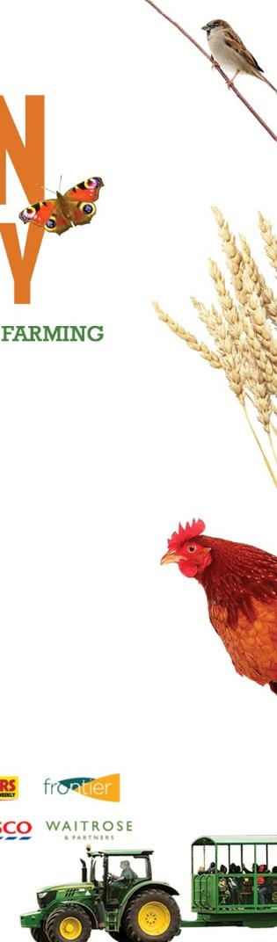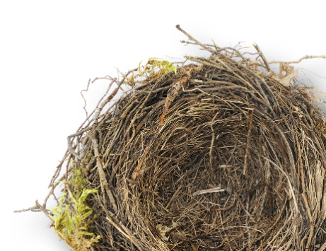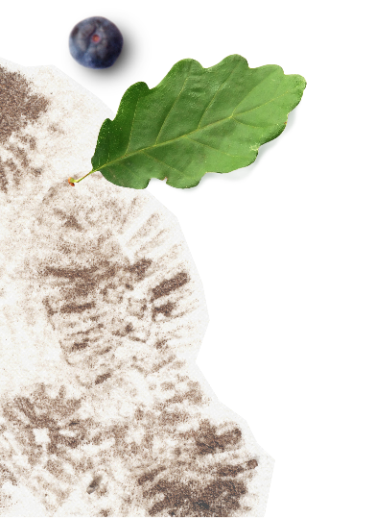

a) 20% b) 40% c) 70%