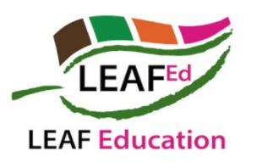

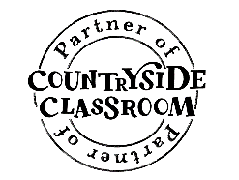

**QUALITY ASSURANCE LABELS**

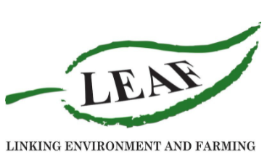

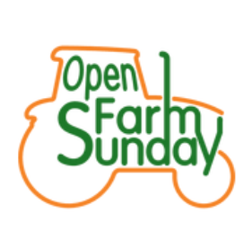

|  |  |  |
| --- | --- | --- |
| **LOGO** | **TYPES OF PRODUCTS LOGO FOUND ON** | **WHAT THEY MEAN** |
|  | * Meat – Beef, lamb, pork, chicken, turkey; * Dairy - milk, cheese, cream; * Cereals and flour; * Fruit, vegetables and salads. | Run by Assured Food Standards, this logo certifies the food was produced in Britain and to certain quality standards for food safety, hygiene, and the environment, and reflects standard industry practice in the UK. |
|  | * Eggs   Covers all methods  of production:  0 = Organic;  1 = Free Range;  2 = Barn;  3 = Caged. | The Lion Mark appears on eggs and ensures they meet food safety criteria. This standard guarantees the eggs were laid in Britain but generally only ensures minimum legislative requirements for animal welfare, so permits the use of 'enriched cages' for hens as well as barn and free-range systems. |
|  | * Beef, lamb and pork; * chicken, duck and turkey; * eggs; * dairy; * salmon and trout. | The scheme covers both indoor and outdoor rearing systems and ensures that greater space, bedding and enrichment materials are provided. In addition, on-farm health and welfare monitoring is required and stunning and slaughter processes are specified. |
|  | * Farming; * food and drink; * beauty and well-being; * textiles. | Soil Association is one of the most widely recognised in the UK and appears on over 70% of all organic products. At least 95% of the ingredients must come from organically produced plants or animals. As well as upholding high environmental standards their standards offer many animal welfare benefits that exceed standard industry practice. |
|  | * Fish; * shellfish. | MSC fisheries are part of a pledge to prevent overfishing and ensure enough fish are left in the sea. The fishery also needs to prove it doesn’t affect other species or ocean habitats and comply with worker’s rights. |
|  | * Quorn Foods; * Kingsmill bread. | The Carbon Trust Footprint logo can be used to show either the carbon or water footprint of a product, or a reduction in the creation of carbon dioxide or water use during production. |
|  | * Fruits and vegetables; * Grains; * Plants and flowers; * dairy products; * meat.   45% of UK fruit and veg is LEAF Marque certified. | Products carrying the LEAF Marque logo operate to sustainable farming standards, for example:   * soil and water management; * pollution control; * crop health; * animal welfare; * community engagement; * energy efficiency; * landscape and nature conservation. |