**Work sheet 2**

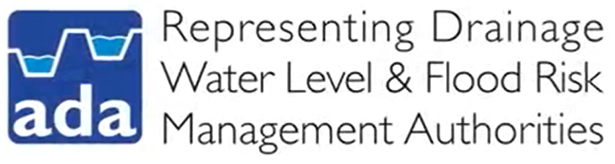



**Annotate the diagram below to suggest other reasons for managing water levels in addition to reducing flood risk.**

