# KAHOOT QUIZ INSTRUCTIONS

## Set up:

A live kahoot is intended to be displayed on a large screen (like a projector connected to a computer) in front of an audience. Members use their own phones to enter your game PIN in our app (can be downloaded free from the app store) or at kahoot.it in their browser to answer questions.

## Initial tech check:

Since Kahoot! is an internet-based service, connectivity is crucial in order to successfully deliver the quiz. If you know that your venue will not have Wifi then you could use a mobile device as a hot spot or you can use the paper version of the quiz in the module email pack.

## Practice to make perfect

Between questions, you can take time to discuss responses with the members – you may want to brainstorm additional information to share during these moments.

## How to deliver a quiz

The best way to start a game is to…  
1. Go to https://kahoot.com and log in to your account or sign up to create an account.

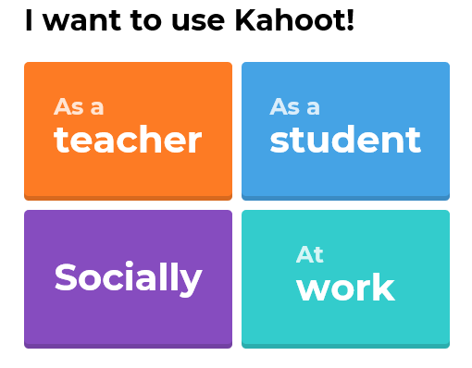

When creating an account click on the ‘As a Teacher’ button.

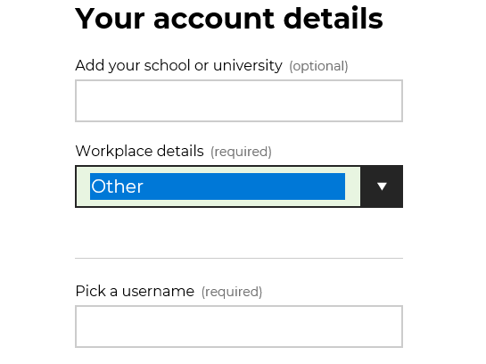  
2. Find the game you want to host – for this module the tile is

Select ‘Other’ when asked your work place details.

**Water Level Management in the UK.**

3. Click “Play” to launch the game. Remember that questions need to be displayed on a big screen so that all players can see.  
4. Choose “Classic” or “Team” mode.  
6. Wait for everyone to join, then click “Start”.  
7. Use spacebar on your keyboard or the “next” button to progress through the game.

## How to play a live kahoot in a group setting?

Live Kahoot!’ing is lots of fun! A live kahoot is best hosted on a large screen (like a projector screen), so that everyone can see the questions. So, you need a device for hosting, and each of the players needs a device for joining the game.



When the game starts, you’ll see a PIN on the screen. Join by entering the PIN in using the Kahoot app or at https://kahoot.it in the browser on your device. On the next step, enter your nickname and check if you see it in the game lobby on the shared screen.

After everyone’s entered the game PIN and a nickname, the large screen will display questions, answer options, and any related images/videos. Review them quickly but carefully. Each answer option is inside a box with a specific colour and shape that match boxes displayed on your own screen. Use your device to answer!

## Quiz – how to play

Choose the answer from multiple options and select the box of corresponding colour and shape on your device before time runs out. Correct answers on quizzes may award points based on your speed of response and consecutive correct responses.